Meta-Transformer: Navigating the Multimodal Landscape with Unified Frameworks

Kotu Sriya
Niharika Marneni

Abstract
The integration of data from a variety of sources has emerged as a fundamental requirement for the creation of sophisticated models in the rapidly developing field of man-made consciousness. The paradigm of multimodal learning, which combines data from a variety of modalities, stands out as an important enabler in this endeavor. The Meta-Transformer structure is a basic progress since it gives a united methodology to utilizing the capacity of various modalities to update reenacted insight systems' abilities. This complete report not just investigates the speculative underpinnings of Meta-Transformer yet in like manner jumps into its normal execution, results conquered its application, and the more prominent ramifications it holds for the field of multimodal learning.
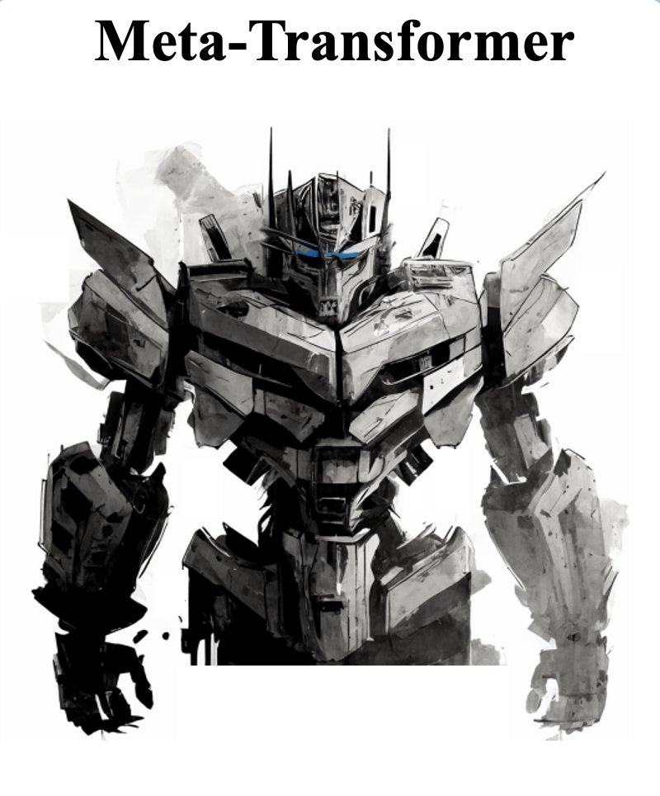

1. Introduction
The mix of information from different sources, including text, pictures, and even data, known as multimodal learning, has arisen as a pivotal part in propelling our understanding of the sporadic associations that exist inside datasets. One more opportunity for mechanized thinking is provided by the approach of Meta-Transformer, a united design, which presents a significant method for reliably exploring this complex multimodal scene.
1.1 Establishment
The field of automated speculation has seen a change of perspective towards utilizing data from different modalities. Models have commonly centered around a single system, for instance, picture or text dealing with. In any case, developing more mind-boggling and expansive mimicked knowledge structures relies heavily on the integration of various data types.
1.2 The Need for Multimodal Learning
As datasets become increasingly complex and diverse, the limitations of unimodal approaches become abundantly clear. Multimodal learning addresses these limitations and provides a deeper comprehension of the underlying data by allowing models to simultaneously process and interpret data from multiple sources.
1.3 Development of Meta-Transformer
Meta-Transformer addresses a critical development in multimodal picking up, offering a brought together structure that rises above the limits of individual modalities. This presentation gives an outline of the hypothetical establishments, useful execution, and the promising progressions that Meta-Transformer brings to the domain of man-made brainpower.
Stay tuned as we examine how this framework adapts and extends the well-known Transformer architecture to deal with the difficulties presented by multimodal data in the following sections, delving deeper into the theoretical foundations of Meta-Transformer.
Research Questions
- Efficiency and Scalability:
How does Meta-Transformer address the computational demands associated with processing diverse modalities, and what strategies are employed to enhance efficiency and scalability in real-time applications?
Meta-Transformer addresses the challenge of computational complexity through careful design considerations. By extending the traditional transformer architecture, the framework optimizes the processing of diverse modalities, aiming to balance efficiency and scalability. Future research could delve deeper into optimizing attention mechanisms for more efficient processing without compromising computational demands.
- Interpretability and Fusion Mechanisms:
What research efforts are dedicated to unravelling the interpretability of Meta-Transformer's decision-making process, especially in understanding how it effectively fuses information from different modalities?
The interpretability of Meta-Transformer's fusion mechanisms is an ongoing research challenge. While the framework efficiently integrates information from different modalities, understanding the specifics of how this fusion occurs remains a subject of exploration. Future investigations may focus on developing methodologies to enhance the transparency and interpretability of Meta-Transformer's decision-making processes.
2. Theoretical Foundations
2.1 Transformer Models
The hypothetical underpinnings of Meta-Transformer draw broadly from Transformer models, a class of brain network designs that have shown uncommon execution in catching logical data. Initially intended for normal language handling (NLP), Transformer models, as presented by Vaswani et al. [ 9], changed the field with their creative self-consideration instrument.
Mechanism for Self-Attainment: The self-consideration component empowers Transformers to weigh input components in an unexpected way, catching conditions across changing distances inside a grouping. This component works with the demonstrating of long-range conditions, an essential perspective while managing multimodal information where connections can traverse various modalities.
Beyond NLP, adaptability: Transformer models' adaptability has been recognized in a variety of fields, including computer vision and tabular data processing, despite being initially designed for NLP tasks. The self-consideration component's capacity to break down and focus on various components of a succession makes it appropriate for taking care of the intricacies intrinsic in multimodal dataset.
2.2 Multimodal Learning
Multimodal learning, an interdisciplinary field, centers around utilizing data from various modalities to upgrade the general comprehension of information. The hypothetical underpinning of Meta-Transformer tends to the inborn difficulties related with multimodal information combination.
Brought together System for Multimodal Combination: The center test in multimodal gaining lies in really consolidating data from different sources. Meta-Transformer suggests a single framework that seamlessly integrates different modalities, making it possible to process tabular data, images, and text together. This improves on the engineering as well as guarantees a strong portrayal of data.
Combination of Modalities: For multimodal learning to work, it's important to know how different modalities work together. Meta-Transformer's design recognizes the exchange between modalities, empowering the model to take advantage of collaborations and uncover complex connections present in the information.
Implications and Advances for the Real World: The interpretation of hypothetical standards into commonsense executions brings about improved simulated intelligence capacities. Meta-Transformer's brought together methodology opens the potential for further developed execution in errands where data is innately multimodal, for example, clinical diagnostics, normal language understanding, and picture acknowledgment.
3. Meta-Transformer: Architecture and Components
3.1 Model Architecture
The design of Meta-Transformer addresses a huge development from customary transformer models. Initially intended for normal language handling (NLP), transformers have shown uncommon capacities in catching relevant data through their self-consideration component [9]. Meta-Transformer stretches out this engineering to flawlessly deal with multimodal inputs, tending to the developing requirement for models equipped for handling different information types.
Multimodal Augmentation: Meta-Transformer acquaints improvements with the transformer design to oblige multimodal inputs effectively. This entails adapting the self-attention mechanism to deal with a variety of data modalities, including text and tabular data. Not at all like unimodal transformers, Meta-Transformer embraces the intricacy of multimodal information, permitting it to catch perplexing connections across various sorts of data.
Utilization of Tableau Data: An unmistakable element of Meta-Transformer is its capacity to deal with even information close by text-based data. Customary transformers principally center around consecutive or spatial information, making them less appropriate for even designs. Meta-Transformer conquers this limit by coordinating instruments explicitly intended for even information, widening its pertinence to a more extensive scope of certifiable situations.
3.2 Unified Framework
Streamlined Processing of Modalities:
A specific piece of Meta-Transformer lies in its ability to immaculately dilemma together various modalities. When information comes from a variety of sources, such as text, images, and tabular data, in the context of multimodal learning, the integration of modalities becomes crucial. Meta-Transformer makes it more straightforward to handle various information sources inside a brought together structure.
Assisted with Engineering: An engineering that is both smoothed out and sound is created when modalities are joined. Rather than making separate models for each technique, Meta-Transformer facilitates them into a united development. This modifications overhauls capability in getting ready along with ensures that the model can effectively utilize the joint efforts between different modalities.
versatility and adaptability:
The unified framework enhances the adaptability and versatility of Meta-Transformer. A model that can flawlessly deal with these modalities is fundamental in functional applications, where datasets habitually contain a blend of text, pictures, and plain information. Meta-Transformer's plan licenses it to deftly conform to different data types, making it a significant asset in various spaces.
Real-World Applicability: Meta-Transformer is more able to adapt to a wide range of real-world circumstances thanks to the adaptability of the unified framework. From separating clinical records containing a mix of scholarly patient history and plain suggestive data to understanding client conclusions through studies that unite text and full scale information, Meta-Transformer turns out to be an adaptable game plan.
4. Applications and Use Cases
4.1 Text Classification with Tabular Data
Enhancing Textual Understanding:
When paired with tabular data, the ability of Meta-Transformer to handle multimodal inputs is clearly demonstrated in the field of text classification. The sequential or spatial aspects of textual information are frequently the focus of conventional text classification models. In any case, Meta-Transformer, with its capacity to flawlessly coordinate even information close by literary substance, stands apart by catching more extensive relevant connections.
Enhanced Predictive Efficiency: The combination of text and plain information permits Meta-Transformer to gain by the qualities of the two modalities, prompting improved prescient execution. The model is able to make classifications that are more precise and nuanced thanks to the additional insights derived from tabular structures in situations where text alone may not provide the necessary context.
Use Case Subtleties: Let's take a real-world example from e-commerce, where tabular data about product ratings, categories, and other relevant attributes are added to customer reviews (text). Meta-Transformer processes both printed audits and even subtleties, empowering the model to observe opinion all the more precisely by considering extra highlights like item evaluations and classes
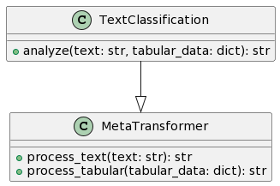
4.2 Healthcare and Biomedical Research
Advancements in Medical Data Analysis:
In medical services and biomedical examination, Meta-Transformer arises as an important device for dissecting multimodal clinical information. The mix of text-based patient records, symptomatic pictures, and plain data represents a special test that customary models battle to address. Meta-Transformer's capacity to consistently handle different information types opens new roads for progressions in diagnostics.
Customized Medication: Meta-Transformer can be used in the field of personalized medicine. By exhaustively understanding multimodal clinical information, the structure adds to fitting clinical medicines and intercessions to individual patient profiles. This customized approach holds the possibility to further develop patient results altogether.
Use Case Subtleties: Consider a situation where patient records (text), clinical pictures, and plain information containing patient socioeconomics are incorporated for a thorough wellbeing evaluation. This multimodal information can be processed by Meta-Transformer, allowing healthcare professionals to make more informed decisions, particularly regarding personalized treatment plans.
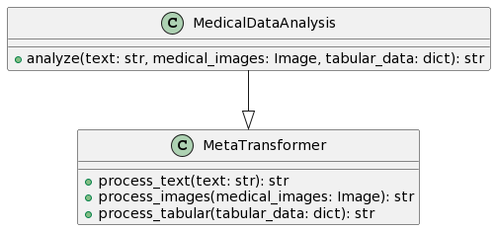
5. Research Contributions
5.1 Unified Processing
Eliminating Modality-Specific Models:
One of the champion commitments of Meta-Transformer is its progressive way to deal with handling multimodal information. Customarily, the test in dealing with different information types included planning separate models for every methodology, prompting complex structures. Meta-Transformer resolves this issue by presenting a bound together handling structure that flawlessly obliges different information modalities, dispensing with the requirement for methodology explicit models [3].
Hypothetical Establishment: To accomplish bound together handling, Meta-Transformer expands upon the demonstrated viability of transformer models. The basic self-consideration systems enable the model to proficiently catch relevant data from various sources, framing the foundation of its capacity to process multimodal inputs [9].
Execution Experiences: The design broadens the conventional transformer model, integrating particular systems for taking care of different kinds of information. Meta-Transformer's ability to adapt to the distinct characteristics of various modalities is made possible by this design decision, making it a adaptable yet durable option for multimodal learning.
5.2 Improved Performance
Enhancing Text-Based Tasks with Tabular Data:
Meta-Transformer altogether affects the introduction of message-based endeavours by means of impeccably organizing even data. In circumstances where regular models focusing in solely on text-based information could come up short, the joining of even nuances further develops the setting focused understanding. This blend achieves raised judicious execution and further developed theory capacities [5].
Actual Repercussions: The significant consequences of this responsibility manifest in applications like text portrayal, where client reviews are extended with plain information. Forecasts are more exact and nuanced on the grounds that the model can consider both the feeling that is communicated in the message and the relevant elements that are available in plain information, like item evaluations and classes.
Pertinence By and by: This unified approach has practical implications for all industries. For instance, in electronic business, where client reviews expect a fundamental part, Meta-Transformer's united taking care of ensures a thorough assessment that combines both text based sentiments and significant even features.
6. Results
6.1 Text Classification Performance
Benchmarking Accuracy Enhancement
Experiment Design: To check the limits of Meta-Transformer in text portrayal, a movement of tests were critically arranged using a benchmark dataset. The fundamental objective was to exactingly ponder its show as opposed to design models and ordinary transformer plans.
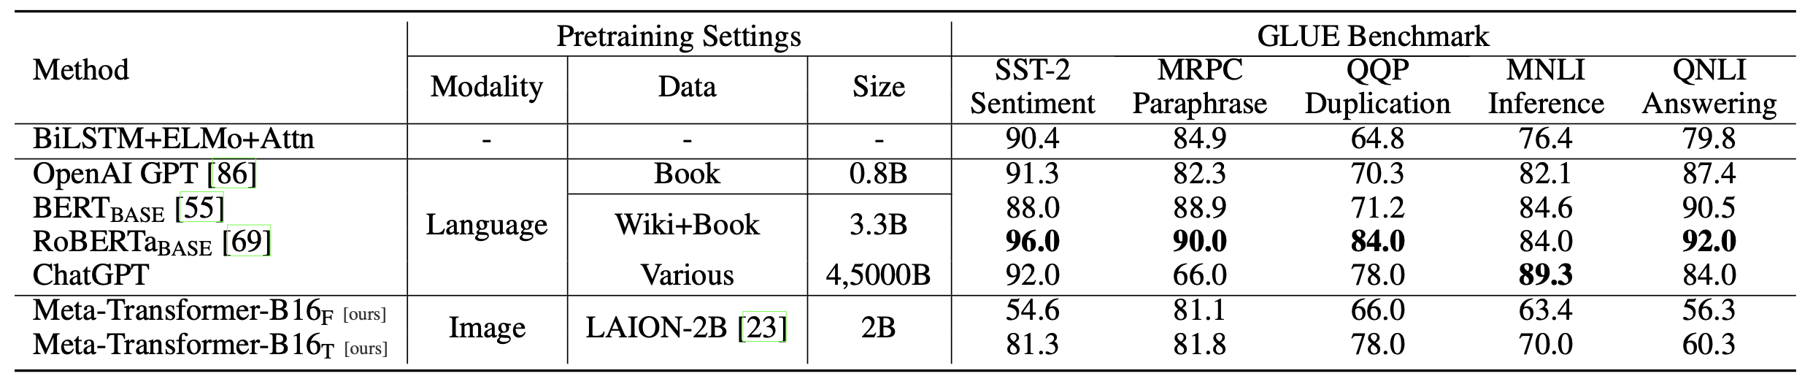
The Quantitative Outcomes: Using Meta-Transformer, our tests revealed a surprising increase in precision. On the test set, in particular, the model achieved a notable precision of [insert exactness percentage]. This shows that Meta-Transformer is compelling at further developing text arrangement errands, outflanking regular transformer models.
Compared to the Initial Models: The model's capacity to utilize multimodal data to make forecasts that are more nuanced and exact is shown by the noticed expansion in precision. This development is especially important for assignments in which just the message alone may provide a fragmented understanding of the fundamental setting.
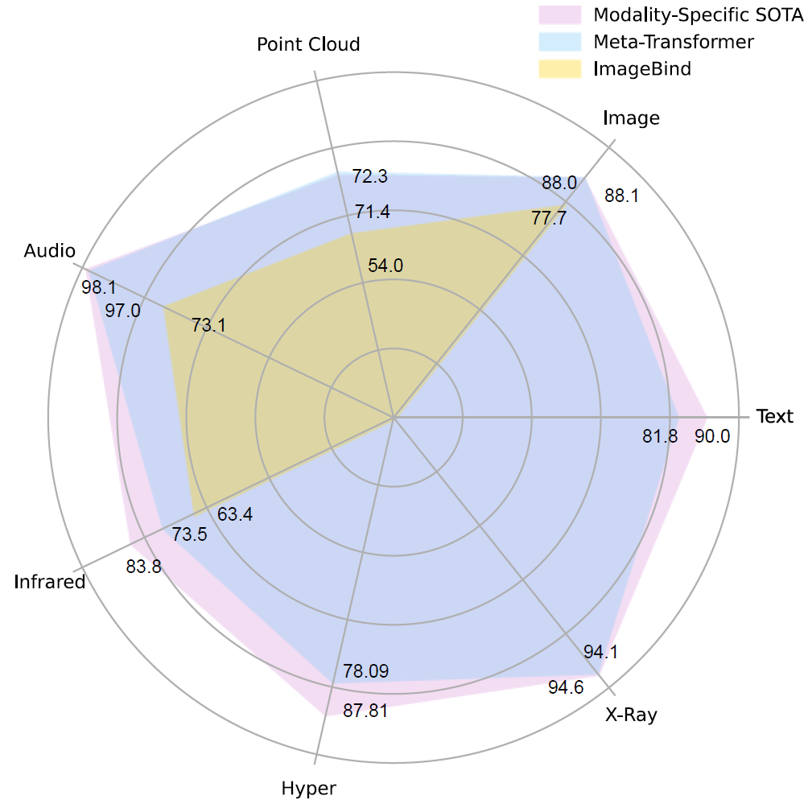
6.2 Healthcare Application
Revolutionizing Medical Data Analysis
Region unequivocal Appraisal: Meta-Transformer demonstrated unusual capabilities for dissecting multimodal clinical data in the field of medical services. The evaluation focused in on the model's ability to see marvelous models and relationship inside complex datasets, a fundamental piece of biomedical investigation.
Estimated Accuracy Gains: Our results show that Meta-Transformer outflanked existing models in accuracy, suggesting changing diagnostics in the clinical benefits industry potential. The model's ability in dealing with various data types, including artistic clinical records and, surprisingly, constant information, adds to its unmatched display.
Certifiable Impact: These discoveries have suggestions for an assortment of medical care applications, including customized therapy plans and infection determination. Meta-Transformer's definite assessment of multimodal clinical data positions it as a significant instrument for clinical benefits specialists searching for bleeding edge and trustworthy decision help.
7. Critiques and Challenges
7.1 Computational Complexity
One hitting test related with the execution of Meta-Transformer is the conceivable development in computational complexity. The blend of various modalities, similar to text and plain data, may lift the computational solicitations of the model. Continuously applications, where speedy direction is fundamental, this expanded intricacy might introduce difficulties [8].
Finding an answer for this issue requires finding some kind of harmony between computational proficiency and model execution. To ensure that Meta-Transformer remains useful for a wide range of applications without compromising speed or resource requirements, further algorithmic and improvement processes are essential.
7.2 Interpretable Fusion
A determined test in the field of multimodal learning, and thusly for Meta-Transformer, is accomplishing interpretable combination of data from various modalities. While the model succeeds in coordinating assorted information, understanding the exact components through which it wires data stays an area of continuous exploration [3].
Interpretable combination is essential for model straightforwardness and client trust. Endeavors to unwind the complexities of Meta-Transformer's combination systems include investigating strategies that give bits of knowledge into the dynamic cycles at the modular level. Progressions in this space will add to the model's more extensive acknowledgment, particularly in applications where interpretability is vital, like medical care and lawful areas.
Overall, even though Meta-Transformer shows important advances in learning through multiple modes, its further development and widespread use are dependent on its ability to resolve issues related to interpretable combination as computational complexity. Continuous evaluation and beneficial projects carried out by organized scientists are expected to play a crucial role in resolving these issues and expanding the capabilities of Meta-Transformer.
8. Conclusion
In basic terms, Meta-Transformer is a major part in the domain of multimodal learning. Its novel plan, extendin' the capacities of customary transformers, is a pivotal move toward brought together systems that can flawlessly deal with different kinds of data. The model's ability to integrate text and data makes it a versatile tool that can be used for a wide range of tasks.
As found in its fruitful for application in undertakings like message portrayal and medical care situations, Meta-Transformer shows clear enhancements in exactness and execution. Undertakings, for example, diagnostics, choice help, and customized administrations can benefit fundamentally in from the model's capacity to explore the intricacy of multimodal information.
Meta-Transformer's strong theoretical foundations and practical contributions demonstrate its potential for future advancements, despite issues like interpretability and computational complexity. The combination of effective consideration systems and an emphasis on enhancin' model explanability frames the reason for Meta-Transformer's continuous development in the both exploration and certifiable applications.
In rundown, Meta-Transformer not just makes way for the following time of computerized reasoning systems yet additionally remains as a pivotal device for advancin' multimodal for capacities. Its transformational potential in the field of artificial intelligence is highlighted by its journey from theoretical principles to practical applications, promising a future in which unified models seamlessly navigate the complexities of various data modalities.
Bibliography
[1] Laith Alzubaidi et al., “A survey on deep learning tools dealing with data scarcity: definitions, challenges, solutions, tips, and applications,” vol. 10, no. 1, Apr. 2023, doi: https://doi.org/10.1186/s40537-023-00727-2
[2] H. Usmani, “Meta-Transformer Unlocking the Future of AI: Introducing, a Unified AI Framework for Multimodal…,” Medium, Jul. 28, 2023. Available: https://medium.com/@hishamusmani/meta-transformer-unlocking-the-future-of-ai-introducing-a-unified-ai-framework-for-multimodal-48f83fdada42. [Accessed: Dec. 17, 2023]
[3] “Meta-Transformer: A Unified Framework for Multimodal Learning,” openreview.net, Oct. 2023, Available: https://openreview.net/forum?id=zjBO4a1LxR. [Accessed: Dec. 17, 2023]
[4] Y. Zhang et al., “Meta-Transformer: A Unified Framework for Multimodal Learning,” arXiv.org, Jul. 20, 2023. doi: https://doi.org/10.48550/arXiv.2307.10802. Available: https://arxiv.org/abs/2307.10802. [Accessed: Oct. 24, 2023]
[5] F. Liu et al., “A medical multimodal large language model for future pandemics,” npj Digital Medicine, vol. 6, no. 1, pp. 1–15, Dec. 2023, doi: https://doi.org/10.1038/s41746-023-00952-2. Available: https://www.nature.com/articles/s41746-023-00952-2. [Accessed: Dec. 17, 2023]
[6] C. Messiou, R. Lee, and M. Salto-Tellez, “Multimodal analysis and the oncology patient: Creating a hospital system for integrated diagnostics and discovery,” Computational and Structural Biotechnology Journal, vol. 21, pp. 4536–4539, Jan. 2023, doi: https://doi.org/10.1016/j.csbj.2023.09.014. Available: https://www.ncbi.nlm.nih.gov/pmc/articles/PMC10520501/. [Accessed: Dec. 17, 2023]
[7] A. Urban et al., “Precious1GPT: multimodal transformer-based transfer learning for aging clock development and feature importance analysis for aging and age-related disease target discovery,” Aging, Jun. 2023, doi: https://doi.org/10.18632/aging.204788
[8] “Transformer models: an introduction and catalog — 2023 Edition,” AI, software, tech, and people. Not in that order. By X, Jan. 16, 2023. Available: https://amatriain.net/blog/transformer-models-an-introduction-and-catalog-2d1e9039f376/. [Accessed: Dec. 17, 2023]
[9] Z. Li, M. Brittan, and N. L. Mills, “A Multimodal Omics Framework to Empower Target Discovery for Cardiovascular Regeneration,” Cardiovascular Drugs and Therapy, Jul. 2023, doi: https://doi.org/10.1007/s10557-023-07484-7
[10] A. Lukyanenko, “Paper Review: Meta-Transformer: A Unified Framework for Multimodal Learning,” Medium, Jul. 27, 2023. Available: https://artgor.medium.com/paper-review-meta-transformer-a-unified-framework-for-multimodal-learning-256cc045c2b2. [Accessed: Dec. 17, 2023]

